School Immunisation Team
Victoria Road
Saltaire
Bradford
BD18 3LD

Tel: 01274 221269

Dear Parent/Career

Alternative porcine (pork gelatine) free flu injection offer for primary aged children in reception to year 6

Flu vaccination is being offered to your child. Most children are offered a nasal spray vaccine which is easy to administer and is considered better at preventing the spread of flu.
The nasal vaccine contains highly processed porcine (pork) gelatine as an essential stabiliser. For those who may not accept the use of porcine gelatine in medicines, a flu vaccine injection is available. If you have not already done so and would like to consent to the flu injection, please follow the steps below to complete your child’s online consent form. The school’s unique codes will remain the same, you will need this to complete the form.
More information is available from www.nhs.uk/child-flu.
To complete a consent please use the guide at the end of this letter.
Once we receive your consent form a member of the team will be in touch to offer your child an appointment at one of our clinics. These are held at various times and dates which include some Saturdays at:
Horton Park Centre
Undercliffe Health Centre
Keighley Health Centre
If you require any further help, please contact the team on 01274 221269 and a member if the team will contact you.

Yours sincerely
Bradford District care Trust
Immunisation team

Guide to completing consent for the injectable flu vaccine
- Enter the following link into your web browser:

www.bradfordschoolimmunisations.co.uk/forms/flu

- Enter and confirm your preferred email address – you will receive a confirmation email following submission of the consent form.

- Enter your Home-School code -
Please complete steps 1-4 below if you wish to consent for injectable porcine (pork gelatine) free flu vaccine:
- Select “no” to consent to the nasal flu immunisation.
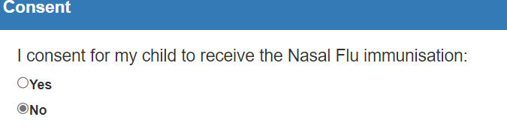
- In the if no box, you must select vaccine content as below to ensure you can access the section in Step 3 to give your consent for the injectable porcine free (pork gelatine) flu vaccine
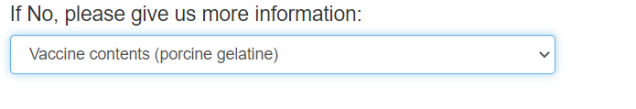
- To give consent answer yes to the question below.
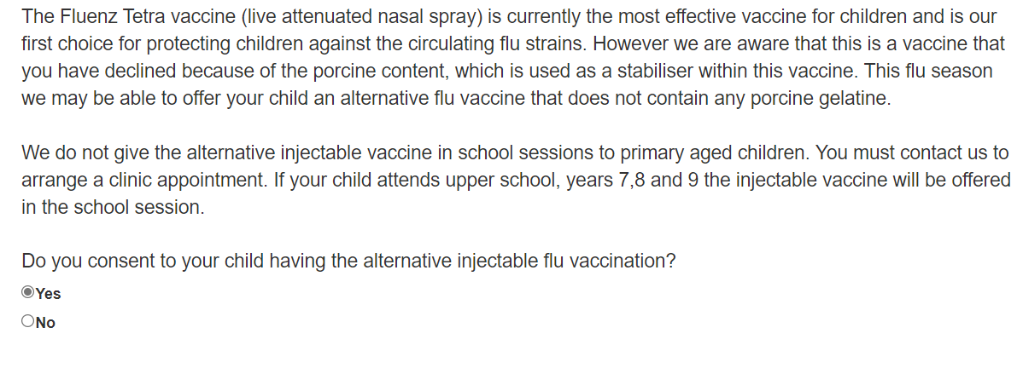
- Complete your details and your relationship with the child along with health questions for your child. Then click submit.


