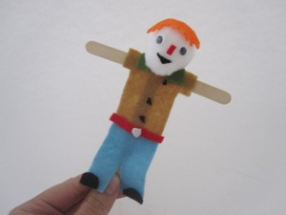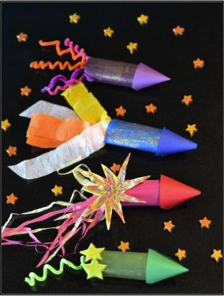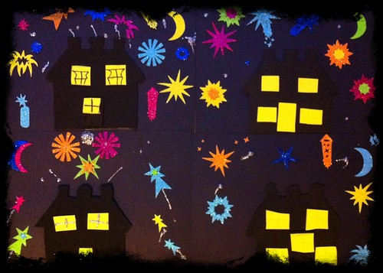[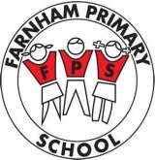](http://www.bing.com/images/search?q=farnham+primary+school&view=detailv2&&id=9425C139830D42A95D992B97F0F9E556F313A595&selectedIndex=0&ccid=OQO5IJAq&simid=608040414966974259&thid=OIP.M3903b920902a28b8952aab70130a9b8ao0)

You can use any available resource, including items from visits, library books and the Internet, but do not just print out web pages.

You can present your project however you would like e.g. a photo, making a model, creating a dance,

poem, song or painting. Use your imagination and get creative.

It is up to you!

Your mini project this term, needs to be based on:

Guy Fawkes and Bonfire Night